SQL Case Study

Case Study
Bike Rental Shop:
Introduction:
Krishna, the owner of a bike shop, wants to collect and analyze data to help her business grow. She has hired you as an SQL specialist to extract valuable insights from the shop’s database. Your task is to write SQL queries that answer key business questions such as:
- How many bikes does the shop own in each category?
- What is the total rental revenue for each month?
All the answers are stored within the database—you just need to uncover them using SQL.
Understanding the database:
The shop's database consists of 5 tables:
Customer

Bike

Rental
Membership_type
Membership

Creating And Inserting Datasets Into The Tables:
Customer Table:
In the first table, Customer, you'll find details about the customers of the bike rental
shop. This table contains the following columns:
- id: The unique ID of each customer.
- name: The customer's name.
- email: The customer's email address
Creating customer table,
create table customer (id int, name char (30), email varchar (30));

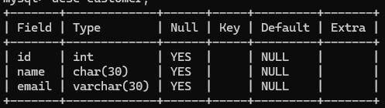
Inserting dataset into customer table,
Insert into customer values(1,'krishna','krishna@gmail.com'),(2,'satish','satish@gmail.com'),(3,'srinu','srinu@gmail.com'),(4,'jagadeesh','jagadeesh@gmail.com'),(5,'suresh','suresh@gmail.com'),(6,'raju','ragu@gmail.com'),(7,'kareem','kareem@gmail.com'),(8,'kishore','kishore@gmail.com'),(9,'ramesh','ramesh@gmail.com'),(10,'mahesh','mahesh@gmail.com');
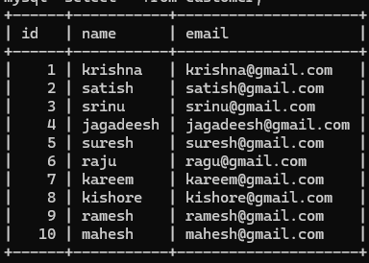

Bike Table:
In the bike table, you'll find information about bikes the rental shop owns.
This table contains the following columns:
- id: The unique ID of the bike.
- model: The model of the bike.
- category: The type of bike (e.g., mountain bike, road bike, hybrid, electric).
- price_per_hour: The rental price per hour for the bike.
- price_per_day: The rental price per day for the bike.
- status: The status of the bike (available, rented, out of service).
Creating bike table,
create table bike (id int , model varchar(50),category varchar(50),price_per_hour decimal,price_per_day decimal,status varchar(30));
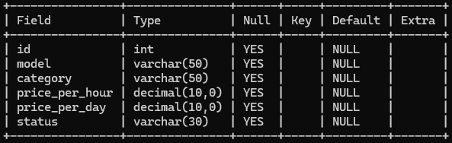
Inserting dataset into bike table,
insert into bike values (1,'Yamaha 1','Sports Bike',10.00,50.00,'available'),
(2,'Royal Enfield Classic 1','Cruiser',12.00,60.00,'rented'),
(3,'KTM Duke 1','Street Bike',8.00,80.00,'available'),
(4,'Yamaha 2','Sports Bike',10.00,40.00,'out of service'),
(5,'Royal Enfield Classic 2','Cruiser',15.00,75.00,'rented'),
(6,'KTM Duke 2','Street Bike',13.00,70.00,'out of service'),
(7,'Yamaha 3','Sports Bike',16.00,85.00,'rented'),
(8,'Royal Enfield Classic 3','Cruiser',11.00,45.00,'available'),
(9,'KTM Duke 3','Street Bike',17.00,87.00,'out of service'),
(10,'Royal Enfield Classic 3','Cruiser',15.00,75.00,'available');
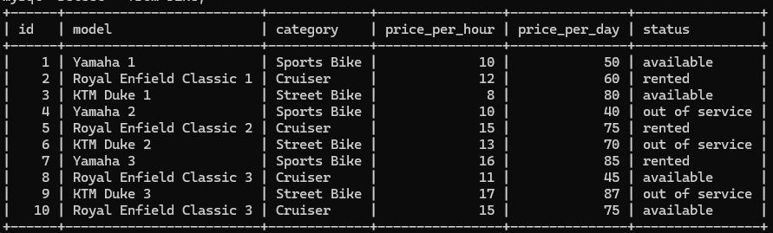

Rental Table:
The rental table matches customers with bikes they have rented. This table has
the following columns:
- id: The unique ID of the rental entry.
- customer_id: The ID of the customer who rented the bike.
- bike_id: The ID of the bike rented.
- start_timestamp: The date and time when the rental started.
- duration: The duration of the rental in minutes.
- total_paid: The total amount paid for the rental.
Creating rental table,
create table rental (id int primary key, customer_id int references customer(id),bike_id int references bike(id),start_timestamp timestamp,duration int,total_paid decimal);
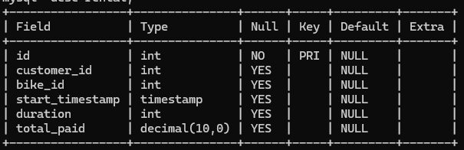
Inserting dataset into rental table,
insert into rental values(1,1,2,'2025-05-01 10:00:00',240,60.00),(2,3,2,'2025-05-02 10:00:00',230,80.00),(3,3,4,'2025-06-02 10:00:00',170,50.00), (4,3,8,'2025-06-07 12:00:00',150,50.00),(5,3,2,'2025-06-04 10:00:00',250,80.00),(6,4,6,'2025-08-12 10:00:00',260,85.00),(7,4,7,'2025-02-13 10:00:00',430,50.00),(8,4,10,'2025-06-12 12:00:00',260,70.00),(9,5,1,'2025-06-20 12:00:00',240,85.00),(10,5,3,'2025-08-04 12:00:00',230,40.00),(11,5,5,'2025-09-22 11:00:00',236,70.00),(12,5,8,'2025-09-05 12:00:00',280,40.00),(13,5,9,'2025-03-10 11:00:00',225,70.00),(14,6,3,'2025-04-20 10:00:00',280,65.00),(15,6,4,'2025-06-09 11:00:00',300,40.00),(16,7,4,'2025-08-16 09:00:00',260,80.00),(17,7,5,'2025-09-22 11:00:00',236,70.00),(18,7,6,'2025-10-08 07:00:00',230,65.00),(19,7,10,'2025-08-21 10:00:00',234,85.00),(20,8,7,'2025-07-03 11:00:00',210,45.00),(21,9,4,'2025-08-01 09:00:00',130,60.00),(22,10,4,'2025-09-15 04:00:00',200,50.00),(23,10,10,'2025-03-12 10:00:00',400,60.00),(24,10,10,'2025-07-18 11:00:00',280,75.00),(25,10,10,'2025-10-18 11:00:00',270,70.00);
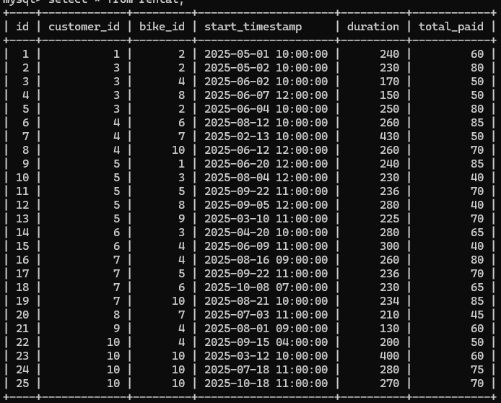
Membership_type:
The membership_type table has information about the different membership types for
purchase. This table contains the following columns:
- id: The unique ID of the membership type.
- name: The name of the membership type.
- description: A description of the membership type.
- price: The price of the membership type.
Creating membership_type table,
create table membership_type(id int primary key,name varchar(50),description varchar(500),price decimal);
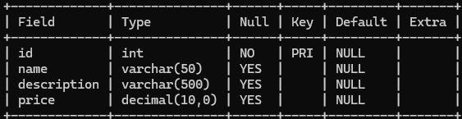
Inserting dataset into membership_type table,
insert into membership_type values(1,'Basic monthly','Basic monthly plan with standard features and 30-day access, perfect for new or casual users.',100.00),(2,'Basic annual’, ‘Basic annual plan with standard features and year-long access at a discounted rate.',500.00),(3,'Premium monthly’, ‘Premium plan offering full access to all features, priority support, and exclusive benefits.',200.00);
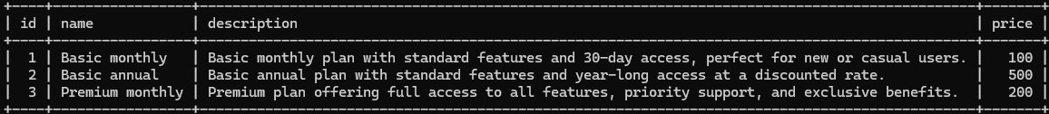

Membership Table:
The membership table has information about individual memberships purchased by
customers. This table contains the following columns:
- id: The unique ID of the membership.
- membership_type_id: The ID of the membership type purchased.
- customer_id: The ID of the customer who purchased the membership.
- start_date: The start date of the membership.
- end_date: The end date of the membership.
- total_paid: The total amount paid for the membership
Creating membership table,
create table membership (id int primary key, membership_type_id int references membership_type(id), customer_id int references customer(id),start_date date, end_date date, total_paid decimal); 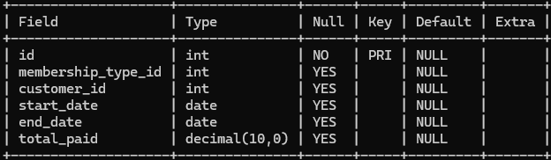
Inserting dataset into membership table,
insert into membership values
(1,2,3,'2025-05-01','2025-05-30',200.00),(2,5,7,'2025-05-01','2025-05-30',100.00),(3,8,6,'2025-05-01','2025-05-30',500.00),(4,7,4,'2025-06-01','2025-06-13',200.00),(5,9,4,'2025-06-01','2025-07-31',500.00),(6,4,8,'2025-07-01','2025-07-31',100.00),(7,1,6,'2025-08-01','2025-08-30',500.00),(8,4,2,'2025-08-01','2025-08-30',200.00),(9,7,8,'2025-09-01','2025-09-20',100.00),(10,3,10,'2025-09-01','2025-09-24',200.00),(11,6,1,'2025-09-01','2025-09-03',100.00),(12,7,4,'2025-09-01','2025-10-30',500.00),(13,5,8,'2025-10-01','2025-10-31',200.00),(14,6,3,'2025-10-01','2025-10-31',200.00),(15,2,3,'2025-10-01','2025-10-23',100.00);

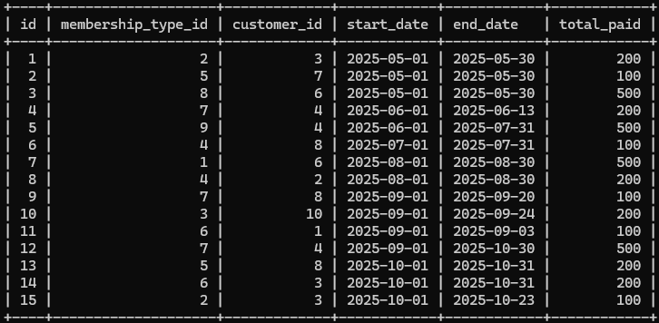

Problem Statements And Solutions:
Following are the business questions that Krishna wants answers to. Use SQL to
answer them. All the best.
- Krishna would like to know how many bikes the shop owns by category. Can
you get this for her?
- Display the category name and the number of bikes the shop owns in
each category (call this column number_of_bikes). Show only the categories
where the number of bikes is greater than 2.
Solution:
select category, count(1) as number_of_bikes from bike group by category having count (1) > 2;
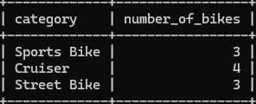

- Krishna is working on a special offer for the winter months. Can you help her
prepare a list of new rental prices?
- For each bike, display its ID, category, old price per hour (call this column old_price_per_hour), discounted price per hour (call it new_price_per_hour), old price per day (call it old_price_per_day), and discounted price per day (call it new_price_per_day).
- Electric bikes should have a 10% discount for hourly rentals and a 20% discount for daily rentals. Mountain bikes should have a 20% discount for hourly rentals and a 50% discount for daily rentals. All other bikes should have a 50% discount for all types of rentals. Round the new prices to 2 decimal digits.
Solution:
select id, category, price_per_hour as old_price_per_hour, case when category = 'electric' then round(price_per_hour - (price_per_hour*0.1) ,2) when category = 'mountain bike' then round(price_per_hour - (price_per_hour*0.2) ,2) else round(price_per_hour - (price_per_hour*0.5) ,2) end as new_price_per_hour, price_per_day as old_price_per_day, case when category = 'electric' then round(price_per_day - (price_per_day*0.2) ,2) when category = 'mountain bike' then round(price_per_day - (price_per_day*0.5) ,2) else round(price_per_day - (price_per_day*0.5) ,2) end as new_price_per_day from bike;
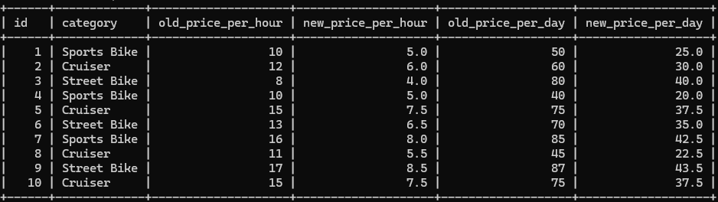

- Krishna is looking for counts of the rented bikes and of the available bikes in each category.
- Display the number of available bikes (call this column available_bikes_count) and the number of rented bikes (call this column rented_bikes_count) by bike category.
Solution:
select category, count (case when status ='available' then 1 end) as available_bikes_count, count(case when status ='rented' then 1 end) as rented_bikes_count from bike group by category;
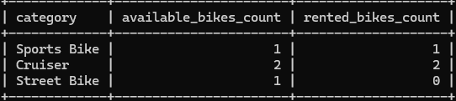
- Krishna is preparing a sales report. She needs to know the total revenue from rentals by month, the total by year, and the all-time across all the years.
- Display the total revenue from rentals for each month, the total for each year, and the total across all the years. Do not take memberships into account. There should be 3 columns: year, month, and revenue.
- Sort the results chronologically. Display the year total after all the month totals for the corresponding year. Show the all-time total as the last row.
Solution:
select extract (year from start_timestamp) as year, extract (month from start_timestamp) as month, sum(total_paid) as revenue from rental
group by extract (year from start_timestamp), extract (month from start_timestamp)
union all select extract (year from start_timestamp) as year, null as month, sum(total_paid) as revenue from rental
group by extract (year from start_timestamp) union all select null as year, null as month, sum(total_paid) as revenue from rental order by year, month;
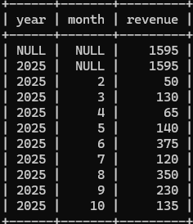
- Krishna has asked you to get the total revenue from memberships for each combination of year, month, and membership type.
- Display the year, the month, the name of the membership type (call this column membership_type_name), and the total revenue (call this column total_revenue) for every combination of year, month, and membership type. Sort the results by year, month, and name of membership type.
Solution:
select extract (year from start_date) as year, extract(month from start_date) as month, mt.name as membership_type_name, sum(total_paid) as total_revenue from membership m join membership_type mt on m.membership_type_id = mt.id group by year, month, mt.name order by year, month, mt.name. 